Distribution of time from symptom onset to treatment initiation in visceral leishmaniasis: Analysis using Brazil’s national surveillance system (SINAN), 2007–2023
Juan Sebastian Hurtado-Zapata^{,1,2,3,5}, James P. Wilson^{1,2}, Glaucia Cota⁴, Dawit Getachew Assefa^{1,2,}, Makoto Saito^{1,2}, Philippe J Guerin^{1,2}, Neal Alexander³, Prabin Dahal^{1,2*}
¹Infectious Diseases Data Observatory (IDDO), Oxford, UK
²Centre for Tropical Medicine and Global Health, Nuffield Department of Medicine, University of Oxford, Oxford, UK
³Centro Internacional de Entrenamiento e Investigación Médica - CIDEIM, Universidad ICESI, Cali, Colombia.
⁴Instituto René Rachou, Fiocruz Minas, Belo Horizonte, Minas Gerais, Brazil
⁵Clinical Research and Leadership Program TDR/WHO

Shorthand title: Delayed treatment initiation in Visceral Leishmaniasis in Brazil

*Correspondence:
prabin.dahal@ndm.ox.ac.uk
Infectious Diseases Data Observatory (IDDO), Oxford, UK

Abstract
Background: Prompt diagnosis and treatment remain a key pillar of global Visceral Leishmaniasis (VL) control. In particular, the distribution of the time from system onset to treatment initiation remains poorly characterised and is yet to be fully understood. Therefore, the impact of delayed treatment initiation on treatment outcomes remains largely unexplored in Brazil.
Methodology:

Introduction
Visceral leishmaniasis (VL) (kala-azar) is the most severe form of human leishmaniasis and, if untreated, is highly lethal (1,2). It is caused by protozoa of the genus Leishmania and transmitted by infected phlebotomine sandflies (3). Clinical presentation typically includes prolonged fever, hepatosplenomegaly, pancytopenia, progressive cachexia and, in advanced cases, multiorgan failure and bleeding. Immunosuppression (notably HIV coinfection) and malnutrition markedly worsen prognosis (4,5). Without adequate care and appropriate therapy, case fatality can exceed 95% within 2 years (6,7).
The disease has four primary endemic foci: the Indian sub-continent (ISC), Eastern Africa, the Mediterranean region and Latin America (8,9). In Latin America, Brazil remains the most affected country, accounting for about 90% of cases and approximately 3,000 to 4,000 cases, with an incidence of 1.68 to 1.84 cases per 100,000 inhabitants over the past 10 years. Treatment remains available freely through the government healthcare system (10,11). Despite this, the case fatality rate remains high at around 10% (12,13). A key strategy to combat the disease and prevent mortality is to promptly identify the cases and initiate treatment; this has been a cornerstone of VL control globally (14), and one of the main objectives of the Brazilian VL surveillance and control program {ref}. However, some studies have reported that patients do not always receive treatment in a timely manner, especially when measured by the time between the first contact with a health-care provider and diagnosis (15–17). Such delays can substantially affect the patient profile at presentation and potentially affect the treatment outcomes. These have particularly been undertaken in the context of ISC and EA, which have highlighted the role of delayed diagnosis and prolonged illness duration in treatment outcomes (18,19). In the context of Brazil, while the role of illness duration has been studied, such evaluations have typically relied on small studies or focused on a narrow geographical unit (15). In particular, the distribution of the time from system onset to treatment initiation remains poorly characterised and is yet to be fully understood. Therefore, the impact of delayed treatment initiation on treatment outcomes remains largely unexplored in Brazil.
In Brazil, VL is recognised as a notifiable disease. This means that all cases that come into contact within the health system must be reported to the national surveillance system, the Notifiable Diseases Information System (SINAN) (20). The SINAN system captures a rich set of information on patients, including the time of system onset, the date of disease confirmation, the time of treatment initiation, and subsequent patient outcomes. The SINAN database, therefore, provides a unique opportunity to characterise the distribution of time between symptom onset and treatment initiation and to investigate the role of delayed treatment initiation in patient outcomes. (15). This study utilises the open-access SINAN database from 2007 through to 2023 and addresses the following specific objectives:
- Characterise the distribution of the gap between symptom onset and treatment initiation across different sociodemographic and clinical groups, and
- Quantify the effect of the gap between symptom onset and treatment initiation on subsequent mortality.
Findings from this analysis may provide insights to policymakers and public health professionals in Brazil towards patient management and disease control.

Methodology
Study setting and population
Brazil is a federal nation with an area of approximately 8.5 million km² and an estimated population of about 215 million in 2023. Administratively, the country is organized into five macro-regions (North, Northeast, Central-West, Southeast, and South), 26 states, the Federal District, and approximately 5,500 municipalities, each differing considerably in demographic composition, population density, and levels of urbanisation. Population distribution is highly varied: the Southeast region contains the country’s largest metropolitan areas and accounts for most of the national population, whereas the North region, which includes Amazonian territories, is characterised by low population density, large rural expanses and considerable geographic expanse (16).
Data source
Data were obtained from the publicly accessible SINAN database maintained by the Brazilian Ministry of Health via the DATASUS platform (23). Since 2007, SINAN has adopted a standardised case notification form for VL, ensuring consistency in data capture. The form includes information on the patient’s demographic, clinical, diagnostic, and treatment-related characteristics. Some of the key information captured includes patient demographics such as age, sex, race/colour and geographic location, clinical characteristics at presentation such as oedema, fever, cough, information regarding time stamps such as time of symptom onset, time when diagnosis was made, and when treatment was initiated, and date of discharge or end of the follow-up. Information is also recorded for geographical details, such as federative units and municipalities. Other patient characteristics, such as VL–HIV coinfection, details of the drug regimens used, and treatment outcomes, are also captured.

Eligibility criteria for inclusion
Records within the SINAN system captured between 2007 and 2023 were eligible for inclusion in this analysis if they satisfied the following criteria:
- VL new confirmed using molecular and/or parasitological methods,
- The date of symptom onset and the date when treatment began were both available,
- Treatment outcome and the date of closure for the following were recorded.
Records were excluded when the diagnostic confirmation was based on epidemiological criteria, or when one of the critical timestamps required to calculate the primary exposure of interest was missing, or when evidence of duplication was detected across notifications. Records where there was a discrepancy between the time of symptom onset and treatment initiation, i.e., time of treatment appearing before the time of symptom onset or it was identical, were also excluded. Finally, patients considered outliers (above the 99th Percentile) in the time between symptom onset and treatment, and those with more than 365 days between treatment initiation and outcome, were excluded.
Exposure and outcome
The primary exposure variable, treatment delay, was defined as the number of days between the reported date of symptom onset (t_{s}) and the date of treatment initiation (t_{t}), calculated as the sum of the time elapsed between t_{s} and diagnosis (t_{d}) and the time between t_{d} and t_{t}. The total delay (tₛ → tₜ) was calculated as the sum of these two intervals and treated as a continuous variable. For some descriptive and graphical analyses, delay was also categorised using clinically interpretable cut-offs (<30, 30-89, 90-120, >120 days) based on the effects and prognoses of the diseases from observational studies conducted in Ethiopia, Peru, Georgia, and South Sudan (18).
Outcome definition
The primary outcome was VL-attributed mortality following treatment initiation, as recorded in the SINAN outcome field. Secondary outcomes included all-cause mortality and time to cure. For time-to-event analyses, follow-up began at the date of treatment initiation and continued for up to 365 days. Individuals were censored at the earliest occurrence of cure, death from causes other than VL, loss to follow-up, or 365 days of follow-up.
As a secondary outcome, we assessed the relationship between treatment delay and disease severity at presentation. We conducted this analysis focusing on the presence of severe clinical manifestations recorded at the time of notification. Clinical manifestations were defined a priori based on established clinical relevance and prior literature (4,6,19). Three indicators: oedema, jaundice and haemorrhagic manifestations were considered markers of advanced or complicated visceral leishmaniasis. These variables were analysed individually and in combination.
Covariates and conceptual framework
Potential confounders and effect modifiers were identified a priori based on clinical relevance, existing literature, and availability across the study period. These included:
- Demographic variables: age group, sex, race/colour, and education level.
- Clinical variables: presence of key signs and symptoms at the time of notification.
- Comorbidity: HIV coinfection status.
- Treatment-related variables: initial treatment regimen.
- Temporal variables: year and notification period.
- Geographic variables: region and federative unit.
A directed acyclic graph (DAG) was constructed to guide confounder selection and avoid inappropriate adjustment for mediators or colliders (20).
Statistical analyses
Continuous variables were summarised using medians and interquartile ranges (IQRs), and categorical variables using frequencies and percentages. Median delays were calculated separately for: i) Symptom onset to diagnosis ($t_{s}$ → $t_{d}$), ii) diagnosis to treatment initiation ($t_{d}$ → $t_{t}$) and iii) total delay ($t_{s }$→ $t_{t}$).
These summaries were stratified by demographic, clinical, temporal, and geographic characteristics, as well as by treatment outcome. Temporal trends were examined across four predefined periods (2007–2009, 2010–2014, 2015–2018, and 2019–2023). Finally, Geographic variation in treatment delay was visualised using choropleth maps at the federative unit level.
Factors associated with treatment delay
To identify predictors of treatment delay, linear regression models were fitted with log-transformed total delay as the dependent variable. Results were expressed as geometric mean ratios with 95% confidence intervals. Multivariable models included covariates selected a priori based on the conceptual framework and data completeness.
Evaluation of primary outcome
Survival analysis: Kaplan-Meier
The relationship between treatment delay and VL-related mortality was quantified within one year of treatment initiation using a time-to-event framework. The time origin (t₀) for survival analyses was the date of treatment initiation, and individuals were censored at cure, non-VL death, loss to follow-up or 365 days of follow-up (right-censoring). The Kaplan-Meier method was used to estimate survival, and the results were presented at different cut-offs of the primary exposure variable previously defined.
A Cox regression model was used to investigate the relationship between the primary exposure variable and mortality, employing a flexible approach to modelling the potential nonlinearity of the exposure effect. Nonlinearity in the Cox model was investigated using splines or by adopting flexible parametric/Royston-Parmar models. All covariates incorporated in descriptive and multivariable analyses, including demographic variables, clinical indicators, comorbidity status, and geographical identifiers, were selected based on predefined relevance (biological or epidemiological) and availability across the full study period.
Evaluation of secondary outcomes
Composite severity categories were constructed to explore dose–response patterns between symptom burden and treatment delay: i) No severe symptoms, ii) at least one severe symptom (either oedema, jaundice or haemorrhage) and iii) Both severe symptoms present (oedema and haemorrhage). By the last, a further composite indicator captured the overall symptom burden.
The association between treatment delay and severe clinical manifestations was evaluated using multivariable logistic regression. The dependent variable was the presence of severe symptoms at notification, and the primary exposure was treatment delay, modelled as a continuous variable using a restricted cubic spline to smooth its effect and distribution. Odds ratios (ORs) and corresponding 95% confidence intervals were estimated to quantify the association between increasing delay and the probability of presenting with severe symptoms. Treatment delay was scaled to improve the interpretability of effect estimates.
Stratified and interaction analyses
According to the clinical relevance of HIV coinfection, analyses were stratified by HIV status (HIV-positive, HIV-negative). Separate models were fitted within each stratum to evaluate the association between treatment delay and severe manifestations. Effect estimates were presented graphically to facilitate comparison across strata.
Ethics
This study used pseudonymised, publicly available secondary data from the SINAN system. In accordance with Brazilian National Health Council Resolution No. 466/2012, research ethics committee approval was not required for analyses of pseudonymised public data. ￼

Results
Between 2007 and 2023, a total of 151,604 VL notifications were reported to the SINAN system. After applying the eligibility criteria, 35,186 patient records were included for presenting a descriptive summary of the time between symptom onset and treatment initiation. Of these, 26,537 individuals had complete outcome information on treatment and were included in the analysis investigating the association between delayed treatment initiation and patient outcome (Figure 1).
The median age of the patient at presentation was 17.5 years [IQR: 3.1 – 39.8; range: 0-104]. Overall, the age distribution was children under five years old (34%) and adults aged 16–50 years (38%). Most cases occurred in males (64%), individuals of brown race/colour (70%), and residents of the Northeast region (47%). VL-HIV coinfection was recorded in 7.3% of cases, although HIV status was missing for 20% of notifications (Table S2). Overall, 9,657 (27.2%) cases were from 2007-2010, 11,872 (33.7%) from 2011-2015, 10,675 (30.3%) from 2016-2020, and 3,072 (8.73%) from 2021-2023.
Distribution of time from symptom onset to treatment initiation
Overall, the median time from symptom onset to treatment initiation (tₛ → tₜ) was 27 days (IQR: 14–55; range: 1-372). This interval was driven primarily by delays between symptom onset and diagnosis, while the median time from diagnosis to treatment initiation was 0–1 day across most subgroups (see Table 1). Treatment delay from symptom onset varied substantially by age. Children under 1 year had the shortest median delay (19 days), while adults aged 16–50 years and those aged over 50 had the longest delays (35 and 34 days, respectively). Males had longer median delays than females (31days [IQR: 15-62; range: 1-372] vs 24 days [IQR: 13-47; range: 1-372]).
Temporal trends showed a modest yet consistent reduction in treatment delay by calendar year. Median delays decreased from 31 days in 2007–2009 to 27 days in 2019–2023. Nevertheless, delays remained substantial throughout the study period. Marked geographic heterogeneity was observed. The shortest median delays were recorded in the North (22 days), while the longest were observed in the South (54 days), though the latter accounted for only a very small proportion of cases. The Northeast region, which bore nearly half of the national burden, had a median delay of 31 days. Choropleth maps demonstrated inter-state variability across periods (Figure 2).
Factors associated with delayed treatment initiation
In univariable analysis, X variables were associated with delayed treatment initiation. These were: x, y, z (Table X). In multivariable linear regression models, demographics, years-period, and geographic factors were independently associated with the time between symptom onset and treatment initiation (Table 3). Compared with adults aged 16–50 years, early age groups (under 16 years) had significantly shorter delays, particularly children under one year (adjusted ratio of geometric means [aRGM] 0.52, 95% CI 0.48–0.57). Male sex was associated with longer delay (aRGM 1.03, 95% CI 1.01–1.06). Compared with the 2010–2014 reference period, treatment delays were longer in 2007–2009 and progressively shorter in subsequent periods, with the greatest reduction observed in 2019–2023 (aRGM 0.86, 95% CI 0.83–0.89). In the same way, geographic variation persisted after adjustment. Relative to the Northeast region, shorter delays were observed in the North (aRGM 0.79, 95% CI 0.77–0.82), Southeast (0.85, 95% CI 0.82–0.88), and Centre-West (0.84, 95% CI 0.80–0.88), while substantially longer delays were observed in the South (aRGM 1.45, 95% CI 1.16–1.82). Education level showed weaker and less consistent associations after adjustment. Race/colour was associated with delay in unadjusted analyses, but these associations were not evident in multivariable models, except for individuals classified as Afro-descendants, who experienced longer delays than brown individuals (aRGM 1.09, 95% CI 1.04–1.14). HIV coinfection was associated with longer delay in univariable analyses, but this association was no longer evident after adjustment.
Treatment delay and severity of clinical symptoms
Overall, there were 3,607 (9,9%) patients with bleeding at presentation, 8,379 (24%) with oedema, 7,956 (23%) with jaundice, and 1,527 (4,33%) with bleeding and oedema. In univariable logistic regression, increasing treatment delay was associated with higher odds of presenting with severe symptoms. A strong relationship was observed, with the highest odds among individuals presenting with both oedema and haemorrhage compared with those without severe manifestations. These relationships stayed when adjusted for HIV status (supplemental figure 2).
VL attributable mortality following treatment
Outcome following treatment was available in 28,642 (81.4%), of whom 2,105 (6.8%) died due to VL. The remaining cases correspond to cured patients who are classified as censored. Upon initiation of treatment, 27.7% (1,157/) died within 7 days.The median time from treatment initiation to death was 23 days [ IQR: 11-44; range: 0-365]. This pattern was consistent across age groups, regions, and HIV status (Table S1).
Kaplan–Meier analyses demonstrated a clear gradient of increasing mortality with longer treatment delays (Figure X). Individuals with longer delays experienced higher cumulative mortality within the first year following treatment initiation, reaching 7.6% at 30 days and 10% over the 150 days of follow-up. Using treatment delay categories, a clear gradient in survival was observed (Figure xx). Individuals who initiated treatment within 30 days of symptom onset had the highest survival probability during the one-year follow-up period, with an 8% of reduction in probability at day 50 and a rate of less than 10% after day 100.
Survival progressively decreased with increasing delay, with the poorest outcomes observed among those with delays ≥120 days, with values around 10.3% at day 30. Separation between survival curves occurred early and persisted over time, indicating a sustained adverse effect of prolonged delay on mortality risk. Notably, individuals with intermediate delays (30–89 and 90–119 days) showed overlapping early survival but diverged later in follow-up, suggesting a dose–response relationship between delay duration and mortality. Differences across delay categories were statistically significant based on log-rank testing (p < 0.001).
Relationship between treatment delays and mortality
In a multivariable Cox regression model, an increasing treatment delay was associated with a higher hazard of VL-related death (Figure 5). Flexible modelling approaches indicated a non-linear relationship, with the steepest increase in mortality risk observed at shorter delays, followed by a more gradual increase at longer delays. This association persisted after adjustment for age, sex, HIV status, geographic and region,

Discussion
The median delay was around a month before treatment initiation, with some age-specific variations. The delay was largely due to the delay in the disease diagnosis. Once the diagnosis was made, treatment initiation was relatively quick, with a median time of 0 days from diagnosis confirmation to treatment, suggesting prompt treatment upon confirmation. While the treatment was initiated promptly upon disease confirmation, the generally long gap between symptom onset and confirmation of diagnosis warrants a thorough investigation. One reason for such delay could be that typical VL symptoms at the time of disease onset are non-specific. In some cases, a lack of laboratory testing facilities has been reported, and in such cases, treatment has been initiated solely on clinical findings {Ref 11 of Ana nice et al}.In the SINAN database, there were x% of the cases that were treated solely based on the clinical findings (Supplemental Table X).
In approx. 25% of patients had the disease undetected for more than 56 days. The general distribution of long delays by regions is presented in Supplemental Table X. Such undetected cases can serve as a disease reservoir, and long delays contribute to ongoing disease transmission {ref}. Modelling studies in the ISC context have indicated that delays of more than 40 days can substantially impact disease elimination efforts {Le Rutte}. Such an impact in the context of South America remains to be investigated and may be important for gauging the feasibility of VL elimination in the region. Interestingly, in approximately 25% of the patients, treatment began within 14 days of the symptom onset. This is particularly relevant as the case definition of suspected VL includes a 14-day fever {ref}. The early presentation is particularly from the North and Northeast regions, where the disease is known to be endemic. These findings are similar to those reported by Ana Nice et al. (2019), and early diagnosis within a few weeks of symptom onset has also been reported by Coura-Vital et al. (2014 {ref}).
Our analysis identified several important predictors of delayed treatment onset. First, patient age was associated with the delays. Young children tended to present earlier compared to the older children, adolescents and the adults. The breakdown for indigenous vs rest was constrained by small numbers. HIV Negative patients also tended to present earlier than the confirmed positive cases. AND other risk factors identified?.....
Patients who initiated treatment early had less severe symptoms at presentation. For example, duration of illness was associated with progressively worsening of bleeding, oedema and other symptoms at presentation (Figure X). These findings are corroborated in the literature, as prolonged delay in treatment initiation has been associated with advanced disease progression (severe anaemia, bleeding, secondary infections, organ dysfunction), prolonged hospitalization, and increased risk of unfavourable outcomes such as treatment relapse and mortality (5,6,10).
MOST OF THE DEATHs OCCURRED WITHIN FEW WEEKs
In addition to the progressive worsening of the disease, longer delay was also associated with an increased mortality risk on average, but with some variation. This finding contrasts with previous evaluations from Brazil, which have reported no association between time from onset to diagnosis/treatment and mortality {REFs: Elizabeth et al-2017}. For example, Coure-Vital (2014) reported increasing mortality with increase in time between symptom onset and diagnoses but this was not significant in multivariable analysis{ref}.Whereas Tourinho et al (2017) reported lower risk with longer duration of illness but this was not observed in multivariable model{ref}. Similar finding of no significant association was reported in a cohort of VL-HIV patients {ref: Cota et al, Leishmania-HIV Co-infection: Clinical Presentation and Outcomes in an Urban Area in Brazil | PLOS Neglected Tropical Diseases}. While Cota et al did not find any relationship between the length of disease and death, a few other studies (referenced within the paper) also evaluated the relationship between duration of illness and mortality. In general, a high mortality among those presenting late is partially explained by a rise in disease complexity. Such observations have also been identified in other major endemic regions, such as ISC. Our findings that children have high mortality despite early presentation could be due to the high parasite load harboured in very young children {Ref: Piaui paper, within Ana Alice}.

We also observed a non-linear relationship (U-shaped) between duration of illness and mortality. Patients who presented very early were at a slightly increased risk of mortality before the risk declined and then increased again. The nadir (turning point) was at XXX days before the risk increased again. These findings contrast to previous reports which have reported an increased risk of mortality with longer duration of illness. A key distinction however is that previous studies have typically evaluated the effect of the duration of illness as categories (typically categorised at 4 to 8 weeks) rather than a continuous variable, which could have led to a loss in power to detect the non-linearity. For example, De Arajuo20212 categorised duration at 4 weeks and found a statistically non-significant increase in the risk of mortality with increasing time gap {ref}. While evidence in the context of Brazil is currently lacking, studies from EA and ISC have typically found a shorter duration of illness associated with increased relapse risk. For example, in a large cohort of over 8500 patients in India, Burza et al found progressively lower risk of relapse with increasing duration of illness prior to the seeking treatment {ref}, the findings were further corroborated in a cohort of nearly 1800 patients with duration of illness longer than 8 weeks associated with a decreased risk of relapse {ref}. In the context of South America, such association has been reported by Llanos-Cuentas et al {2004} for patients treated with SSG for cutaneous leishmaniasis in Peru {ref} and by Mar Castro et al in Colombia {ref}. A potential hypothesis for the increased risk among those presenting early could be due to the administration of drugs before the patient reached an effective acquired immunity status as suggested in Llanos-Cuentas et al {2004} and Mar Castro{2017}. However, the generalisability of the mechanism to the context of VL in Brazil and assessment of mortality currently remains unclear and remains important aspect of pathophysiology/immunology of VL case management.

Our analysis has some strengths and limitations. This is based on the national surveillance database and covers a wide span of time from 2007-2023. A pseudonymised version of the database remains publicly available, and multiple nationwide and subnational analyses utilising this unique resource have addressed different epidemiological aspects of the disease (20,23). This has included characterising the spatial-temporal distribution of the disease, mapping and identifying heterogeneity in mortality across federative units, including the identification of mortality hotspots, and assessing the impact of several socio-economic indicators on the disease epidemiology (26). Another specific strength of our analysis is that we have investigated the impact of the delay in mortality using a causal framework. An initial mapping of the predictors identified in the literature was used to develop a causal DAG was used to estimate the impact of the delay on mortality. Such approach avoids over-adjustment (of mediators) bias, prevents collider-stratification bias, and appropriately adjusts for confounders – all remains a major challenge in using observational database. While we have made cautious efforts in avoiding such biases, our analysis is also subject to some inherent bias related to the database.
First, missingness in some key variables and the presence of unmeasured confounders remain a major challenge. For example, disease severity remains a major factor affecting mortality and is not explicitly captured in the SINAN database. However, factors such as bleeding, jaundice and oedema are considered as a proxy for severity and appropriate consideration was made for these in the analysis. Second, time of symptom onset is non-specific and there is likely to be a bias in accurately identifying the time when the symptom began. Third, in a substantial number of patients, the time of treatment initiation and time of death were identical. These challenges are well-established and has also been investigated and explored by Ana Alice etal {2019}.

Conclusions

Declarations
Role of the funding source
The funder of the study had no role in study design, data collection, data analysis, data interpretation, or writing of the report.

Credit taxonomy

References
1. Guerin PJ, Olliaro P, Sundar S, Boelaert M, Croft SL, Desjeux P, et al. Visceral leishmaniasis: Current status of control, diagnosis, and treatment, and a proposed research and development agenda. Vol. 2, Lancet Infectious Diseases; 2002. p. 494–501.
2. Geto AK, Berihun G, Berhanu L, Desye B, Daba C. Prevalence of human visceral leishmaniasis and its risk factors in Eastern Africa: a systematic review and meta-analysis. Vol. 12, Frontiers in Public Health. Frontiers Media SA; 2024.
3. Costa CHN, Chang KP, Costa DL, Cunha FVM. From Infection to Death: An Overview of the Pathogenesis of Visceral Leishmaniasis. Vol. 12, Pathogens; 2023.
4. Abongomera C, van Henten S, Vogt F, Buyze J, Verdonck K, van Griensven J. Prognostic factors for mortality among patients with visceral leishmaniasis in East Africa: Systematic review and meta-analysis. PLoS Negl Trop Dis. 2020 May 1;14(5):1–19.
5. Wilson JP, Chowdhury F, Hassan S, Harriss EP, Alves F, Musa A, et al. Prognostic Models Predicting Clinical Outcomes in Patients Diagnosed with Visceral Leishmaniasis: A Systematic Review [Internet]. 2024. Available from: http://medrxiv.org/lookup/doi/10.1101/2024.03.20.24304622
6. Werneck GL, Batista MSA, Gomes JRB, Costa DL, Costa CHN. Prognostic factors for death from visceral leishmaniasis in Teresina, Brazil. Infection. 2003;31(3):174–7.
7. Abongomera C, van Henten S, Vogt F, Buyze J, Verdonck K, van Griensven J. Prognostic factors for mortality among patients with visceral leishmaniasis in East Africa: Systematic review and meta-analysis. PLoS Negl Trop Dis. 2020 May 1;14(5):1–19.
8. Wamai RG, Kahn J, McGloin J, Ziaggi G. Visceral leishmaniasis: a global overview. J Glob Health Sci 2020 Jun;2(1).
9. José Antonio Ruiz-Postigo, Saurabh Jain, Madjou S, Virrey Agua JF, Maia-Elkhoury AN, Valadas S, et al. Global leishmaniasis surveillance, 2022: assessing trends over the past 10 years [Internet]. Geneva; 2023 Sep [cited 2025 Jul 21]. Available from: https://www.who.int/news-room/fact-sheets/detail/leishmaniasis
10. De Melo EC, Fortaleza CMCB. Challenges in the therapy of Visceral Leishmaniasis in Brazil: A public health perspective. Journal of Tropical Medicine. 2013.
11. Simão JC, Victória C, Fortaleza CMCB. Predictors of relapse of visceral leishmaniasis in inner São Paulo State, Brazil. International Journal of Infectious Diseases. 2020 Jun 1;95:44–9.
12. Zhang SX, Yang GB, Sun JY, Li YJ, Yang J, Wang JC, et al. Global, regional, and national burden of Visceral leishmaniasis, 1990–2021: findings from the global burden of disease study 2021. Parasites and Vectors . 2025 Dec 1;18(1).
13. Panamerican Health Organization. Manual of procedures for leishmaniasis surveillance and control in the Region of the Americas [Internet]. Washington, D.C.; 2024. Available from: https://doi.org/10.37774/9789275127346.
14. Scarpini S, Dondi A, Totaro C, Biagi C, Melchionda F, Zama D, et al. Visceral Leishmaniasis: Epidemiology, Diagnosis, and Treatment Regimens in Different Geographical Areas with a Focus on Pediatrics. Vol. 10, Microorganisms. MDPI; 2022.
15. Nightingale ES, Bindroo J, Dubey P, Priyamvada K, Das A, Bern C, et al. Spatial variation in delayed diagnosis of visceral leishmaniasis in Bihar, 2024. Available from: http://medrxiv.org/lookup/doi/10.1101/2024.03.22.24304732
16. Poloni A, Giacomelli A, Corbellino M, Grande R, Nebuloni M, Rizzardini G, et al. Delayed diagnosis among patients with visceral leishmaniasis. Intern Emerg Med. 2023 Nov 1;18(8):2293–300.
17. Welay GM, Alene KA, Dachew BA. Visceral leishmaniasis treatment outcome and its determinants in northwest Ethiopia. Epidemiol Health. 2016;39:e2017001.
18. Rock KS, Quinnell RJ, Medley GF, Courtenay O. Progress in the mathematical modelling of visceral leishmaniasis.
19. Dial NJ, Croft SL, Chapman LAC, Terris-Prestholt F, Medley GF. Challenges of using modelling evidence in the visceral leishmaniasis elimination programme in India. PLOS Global Public Health. 2022 Nov 1;2(11).
20. Cota GF, de Sousa MR, Rabello A. Predictors of Visceral Leishmaniasis Relapse in HIV-Infected Patients: A Systematic Review. PLoS Negl Trop Dis 2011 Jun 7;5(6):e1153-. Available from: https://doi.org/10.1371/journal.pntd.0001153
21. Maia-Elkhoury ANS, Romero GAS, Valadas SYOB, Sousa-Gomes ML, Lauletta Lindoso JA, Cupolillo E, et al. Premature deaths by visceral leishmaniasis in Brazil investigated through a cohort study: A challenging opportunity? PLoS Negl Trop Dis. 2019 Dec 19;13(12).
22. Diegoli H, Makdisse M, Magalhães P, Gray M. The atlas of variation in healthcare Brazil: remarkable findings from a middle-income country. Research in Health Services & Regions. 2023 Feb 8;2(1).
23. Ministry of Health. National surveillance database of notifiable diseases in Brazil. 2024 [cited 2026 Jan 26]. p. 1–1 Sistema de Informação de Agravos de Notificação (SINAN). Available from: https://datasus.saude.gov.br
24. Costa DL, Rocha RL, de Brito Ferreira Chaves E, de Vasconcelos Batista VG, Costa HL, Nery Costa CH. Predicting death from kala-azar: Construction, development, and validation of a score set and accompanying software. Rev Soc Bras Med Trop. 2016 Nov 1;49(6):728–40.
25. Tennant PWG, Murray EJ, Arnold KF, Berrie L, Fox MP, Gadd SC, et al. Use of directed acyclic graphs (DAGs) to identify confounders in applied health research: review and recommendations. Vol. 50, International Journal of Epidemiology. 2021. p. 620–32.
26. Martins-Melo FR, Lima M da S, Ramos Jr AN, Alencar CH, Heukelbach J. Mortality and Case Fatality Due to Visceral Leishmaniasis in Brazil: A Nationwide Analysis of Epidemiology, Trends and Spatial Patterns. PLoS One. 2014 Apr 3;9(4):e93770-.

Figures and Tables
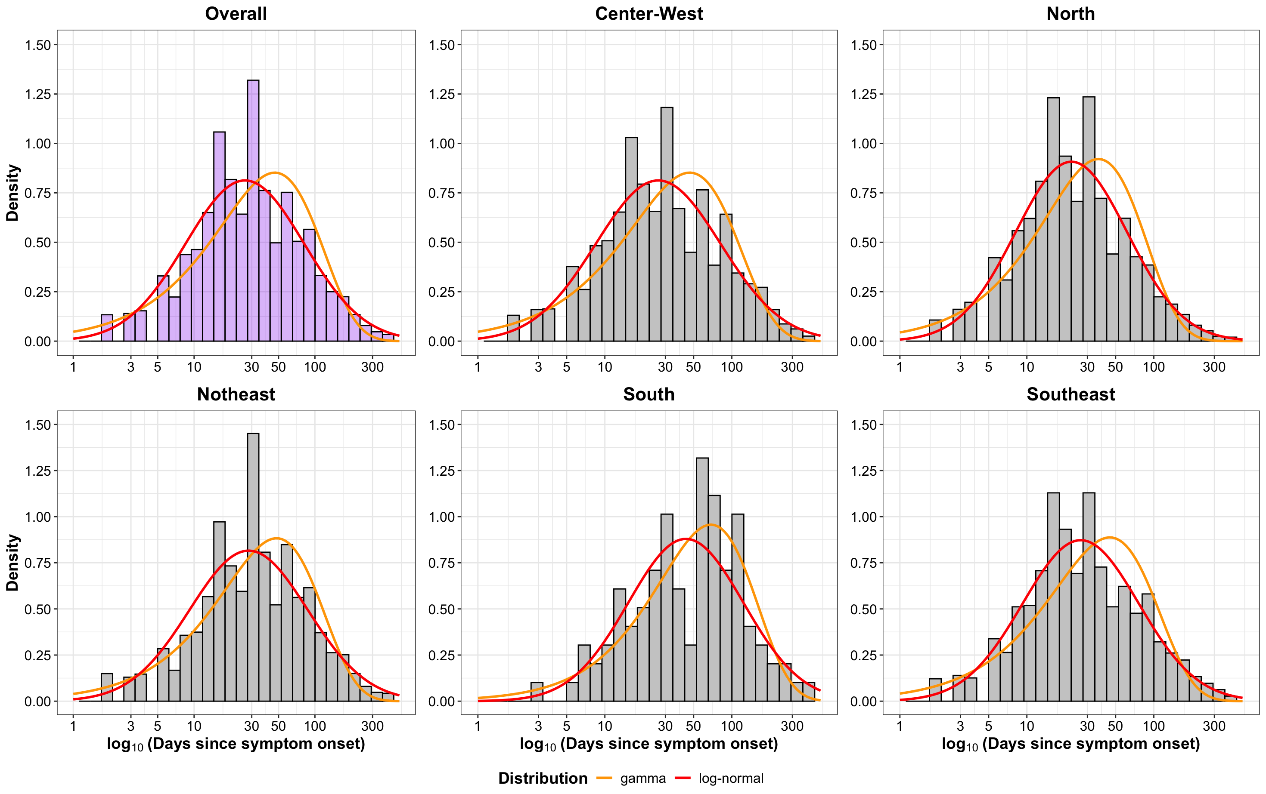
Figure 1. Delay distribution between symptom onset and diagnosis, and diagnosis to treatment

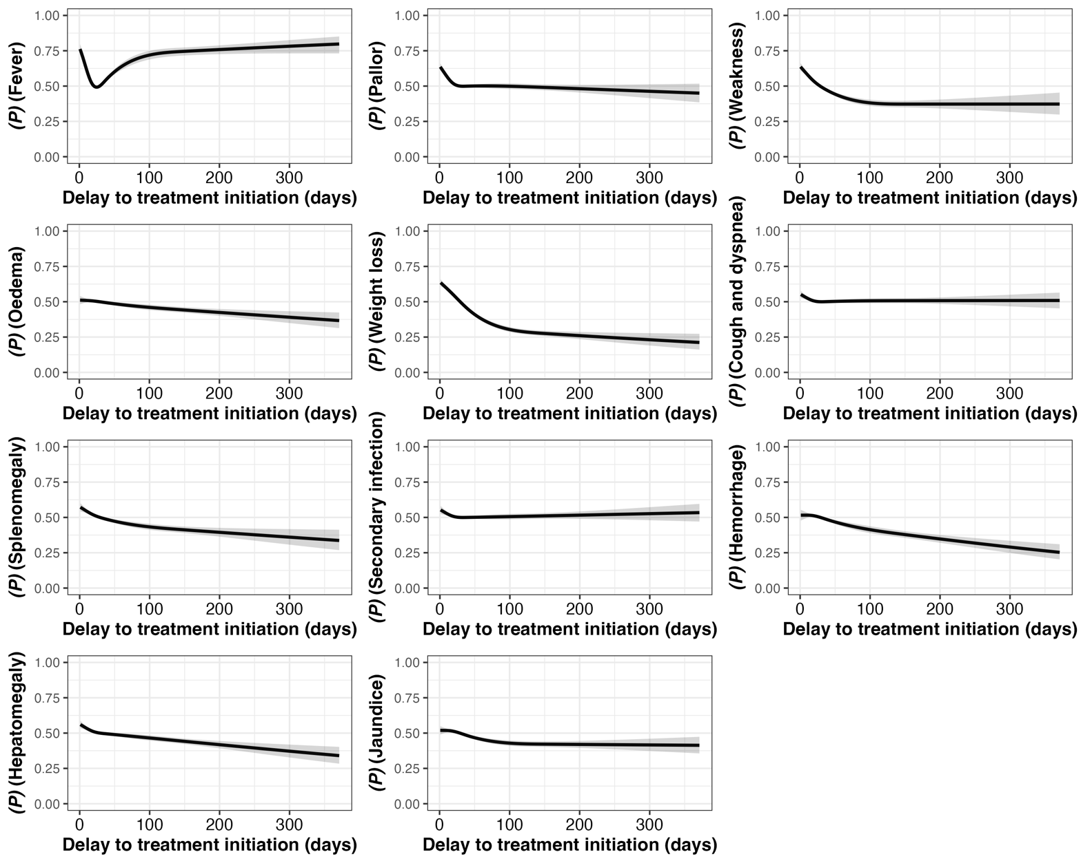

Figure 2. Signs and symptoms at presentation among patients who confirmed HIV negative

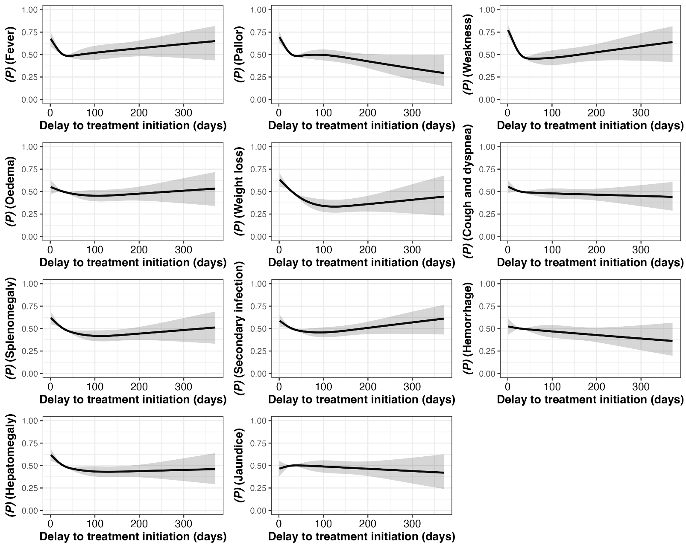

Figure 3. Signs and symptoms at presentation among patients who were confirmed HIV positive

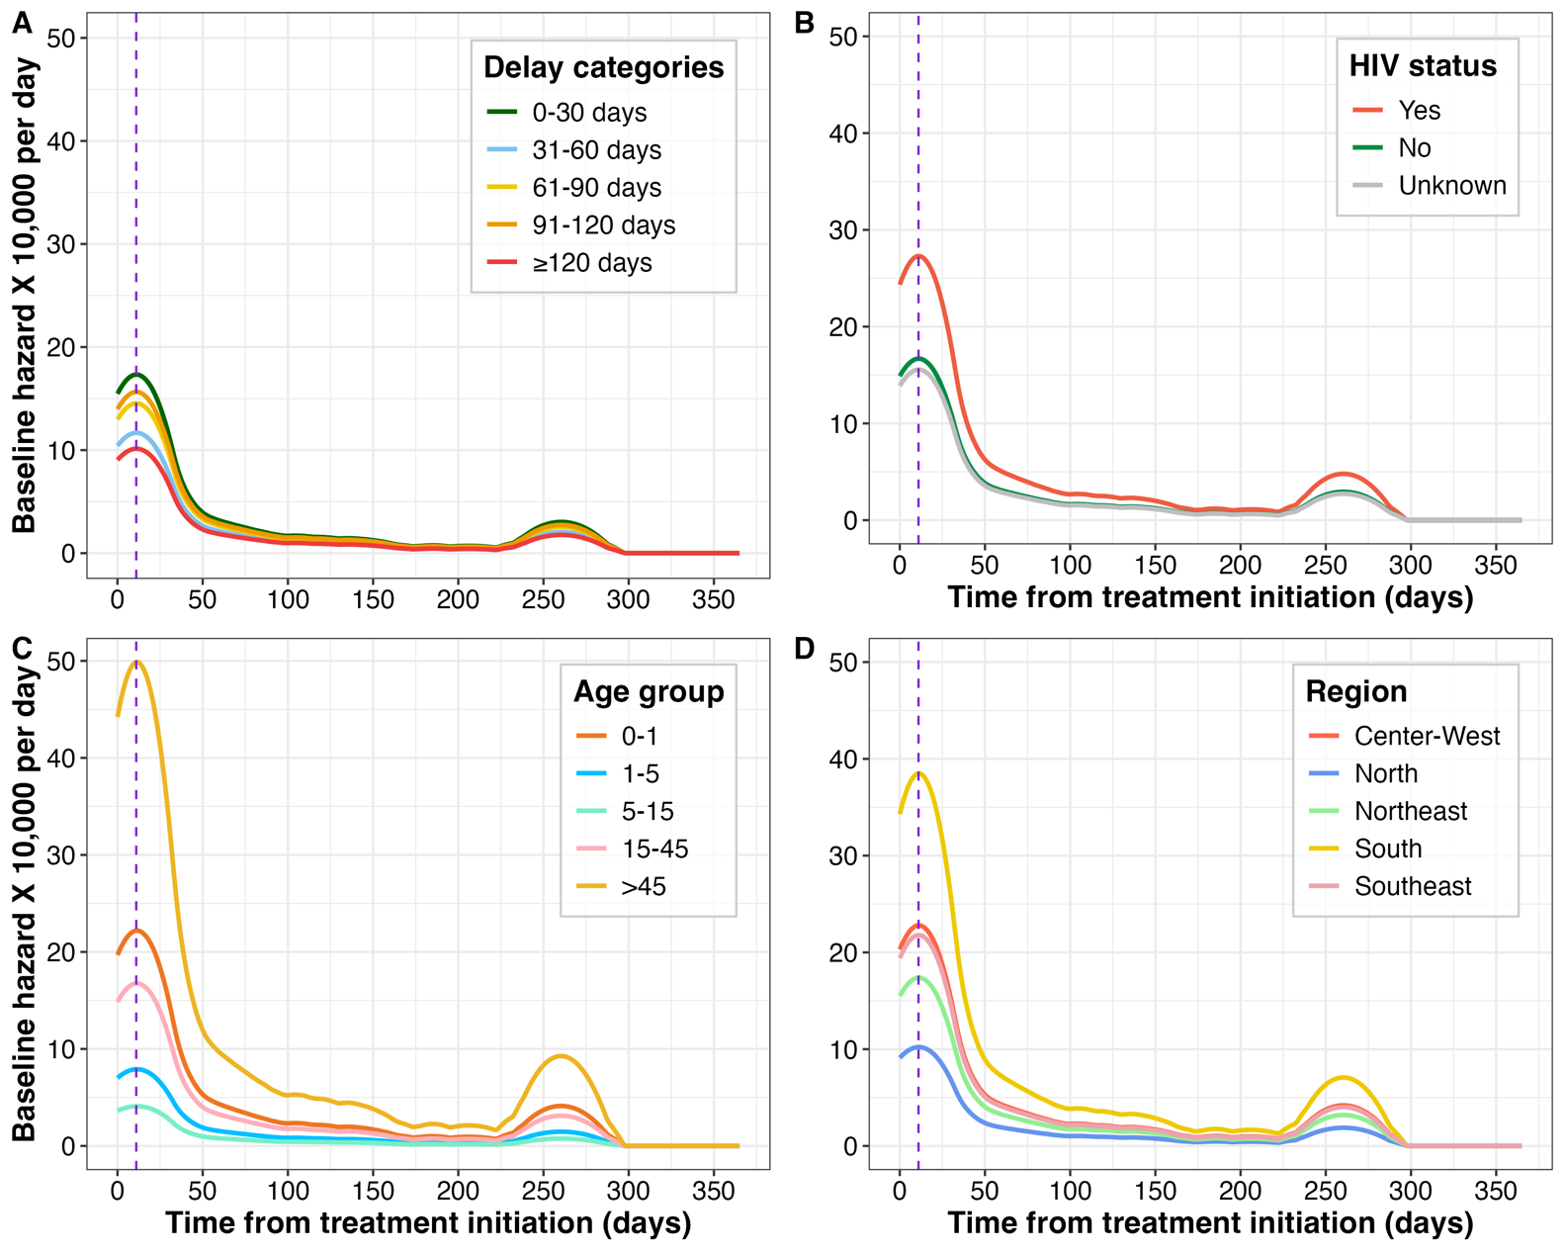
The hazard function estimated using epachnenikov kernel and expressed as per 10,000 person days at risk.

Figure 4. Instantaneous risk of death following treatment initiation

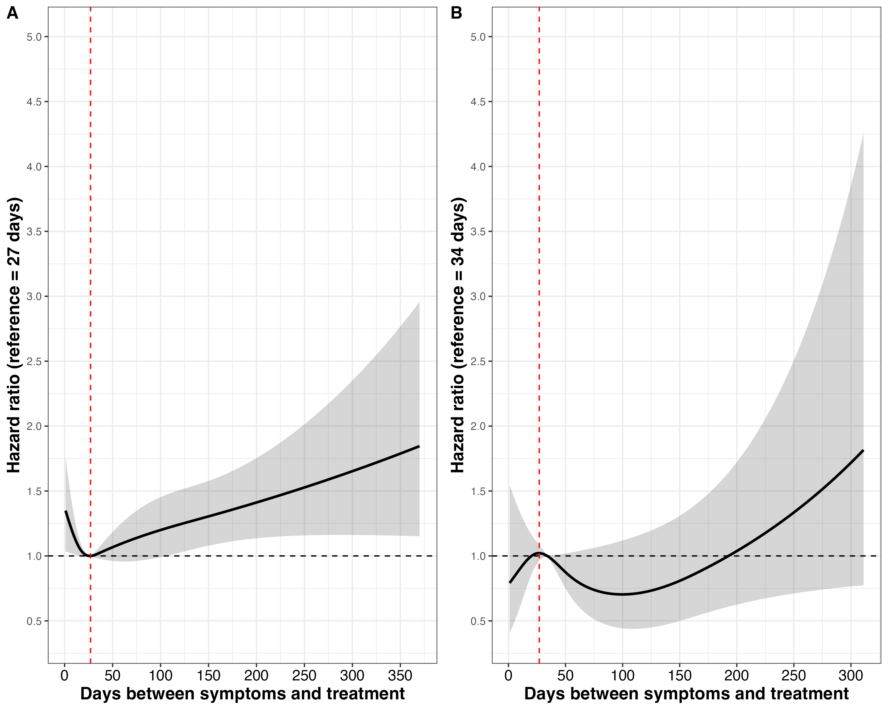
Figure 5. Hazard ratio of mortality by visceral leishmaniasis. Adjusted by gender (female), age (>45), education level (complete elementary and incomplete middle school), race/colour (brown) and region (Northeast). A. No HIV patients and B. HIV patients.
Table 1. Baseline characteristics
Characteristic | Level | n/N | Median time t_{s}-t_{d} | Range t_{s}-t_{d} | Median time t_{d}-t_{t} | Range t_{d}-t_{t} | Median time t_{s}-t_{t} | Range t_{s}-t_{t}
Age group | 0-1y | 2,386/34,928 | 16 [9-31] | 0-340 | 0 [0-2] | 0-132 | 19 [11-32] | 1-340
Age group | 1-5 y | 9,330/34,928 | 18 [10-32] | 0-371 | 0 [0-2] | 0-200 | 21 [12-35] | 1-371
Age group | 6-15 y | 4,907/34,928 | 20 [10-37] | 0-370 | 0 [0-2] | 0-153 | 22 [12-43] | 1-370
Age group | 16-50 y | 13,210/34,928 | 31 [15-68] | 0-372 | 0 [0-3] | 0-364 | 35 [18-73] | 1-372
Age group | >50 y | 5,095/34,928 | 31 [14-67] | 0-371 | 1 [0-4] | 0-149 | 34 [17-72] | 1-371
Gender | Female | 12,554/35,183 | 21 [10-41] | 0-371 | 0 [0-2] | 0-263 | 24 [13-47] | 1-372
Gender | Male | 22,629/35,183 | 28 [12-60] | 0-372 | 0 [0-3] | 0-364 | 31 [15-62] | 1-372
Period (year) | 2007-2009 | 7,134/35,186 | 27 [13-58] | 0-370 | 0 [0-3] | 0-352 | 31 [16-61] | 1-370
Period (year) | 2010-2014 | 12,102/35,186 | 24 [12-53] | 0-372 | 0 [0-3] | 0-364 | 28 [15-59] | 1-372
Period (year) | 2015-2018 | 9,856/35,186 | 23 [11-48] | 0-372 | 0 [0-3] | 0-234 | 28 [14-54] | 1-372
Period (year) | 2019-2023 | 6,094/35,186 | 24 [10-58] | 0-371 | 0 [0-2] | 0-200 | 27 [12-61] | 1-372
Region | Center-West | 2,963/35,186 | 25 [12-59] | 0-371 | 0 [0-1] | 0-149 | 27 [14-61] | 1-371
Region | North | 6,948/35,186 | 16 [8-33] | 0-370 | 2 [0-6] | 0-234 | 22 [12-41] | 1-372
Region | Northeast | 18,088/35,186 | 30 [14-61] | 0-372 | 0 [0-2] | 0-364 | 31 [15-62] | 1-372
Region | Southeast | 7,081/35,186 | 22 [12-50] | 0-371 | 1 [0-3] | 0-352 | 26 [14-56] | 1-372
Region | South | 106/35,186 | 47 [18-87] | 0-366 | 1 [0-3] | 0-69 | 54 [23-93] | 1-366
Education level | Incomplete elementary school | 3,474/26,984 | 30 [14-63] | 0-369 | 0 [0-3] | 0-364 | 33 [16-68] | 1-372
Education level | Complete elementary and incomplete middle school | 4,937/26,984 | 31 [15-68] | 0-371 | 0 [0-3] | 0-352 | 35 [18-72] | 1-372
Education level | Complete middle school and incomplete high school | 2,855/26,984 | 31 [15-62] | 0-372 | 1 [0-4] | 0-153 | 35 [18-67] | 1-372
Education level | Complete high school | 1,733/26,984 | 31 [15-65] | 0-370 | 0 [0-2] | 0-174 | 33 [17-69] | 1-372
Education level | Incomplete university | 146/26,984 | 31 [16-85] | 0-366 | 0 [0-3] | 0-91 | 33 [18-88] | 1-368
Education level | Complete university | 225/26,984 | 31 [16-63] | 0-365 | 0 [0-3] | 0-64 | 35 [21-70] | 1-366
Education level | N/A | 13,614/26,984 | 18 [10-32] | 0-371 | 0 [0-2] | 0-200 | 21 [12-35] | 1-371
Race/colour | Brown | 24,659/34,500 | 25 [11-52] | 0-371 | 0 [0-3] | 0-364 | 29 [14-58] | 1-372
Race/colour | White | 4,881/34,500 | 23 [12-50] | 0-371 | 0 [0-2] | 0-352 | 27 [14-56] | 1-371
Race/colour | Afro-descendants | 2,770/34,500 | 30 [14-64] | 0-372 | 0 [0-3] | 0-121 | 32 [16-68] | 1-372
Race/colour | Yellow | 244/34,500 | 31 [12-63] | 0-356 | 0 [0-3] | 0-70 | 36 [15-68] | 1-356
Race/colour | Indigenous | 347/34,500 | 17 [8-38] | 0-365 | 0 [0-2] | 0-73 | 22 [9-42] | 1-365
Race/colour | Unknown | 1,599/34,500 | 22 [11-48] | 0-369 | 0 [0-2] | 0-152 | 25 [13-53] | 1-371
HIV status | Unknown | 7,111/35,186 | 22 [11-49] | 0-371 | 0 [0-3] | 0-364 | 27 [14-56] | 1-372
HIV status | No | 25,394/35,186 | 24 [12-52] | 0-372 | 0 [0-3] | 0-352 | 28 [14-58] | 1-372
HIV status | Yes | 2,681/35,186 | 31 [14-64] | 0-372 | 0 [0-3] | 0-234 | 34 [17-69] | 1-372
Evolution | Cure | 26,537/31,177 | 22 [11-48] | 0-372 | 0 [0-3] | 0-263 | 27 [14-54] | 1-372
Evolution | Death for VL | 2,105/31,177 | 27 [11-61] | 0-369 | 0 [0-3] | 0-234 | 30 [14-65] | 1-371
Evolution | Death for any-cause | 529/31,177 | 29 [10-62] | 0-366 | 0 [0-3] | 0-123 | 32 [14-67] | 1-367
Evolution | Neglect | 169/31,177 | 25 [8-61] | 0-311 | 0 [0-2] | 0-70 | 32 [10-65] | 1-312
Evolution | Transferred | 1,837/31,177 | 31 [15-62] | 0-372 | 0 [0-2] | 0-364 | 32 [17-65] | 1-372

Table 2. Univariable and multivariable linear regression models, outcome is under a log scale
 | Univariate |  |  | Multivariable
Characteristic | Ratio geometric means | 95% CI | p-value |  | Ratio geometric means | 95% CI | p-value
Age group
16-50 | — | — |  |  | — | —
0-1 | 0.56 | 0.53, 0.59 | <0.001 |  | 0.52 | 0.48, 0.57 | <0.001
1-5 | 0.62 | 0.61, 0.64 | <0.001 |  | 0.59 | 0.55, 0.63 | <0.001
6-15 | 0.69 | 0.67, 0.72 | <0.001 |  | 0.65 | 0.62, 0.68 | <0.001
>50 | 0.98 | 0.95, 1.02 | 0.3 |  | 1.01 | 0.96, 1.05 | 0.8
Gender
Female | — | — |  |  | — | —
Male | 1.17 | 1.14, 1.19 | <0.001 |  | 1.03 | 1.01, 1.06 | 0.011
Period
2010-2014 | — | — |  |  | — | —
2007-2009 | 1.09 | 1.06, 1.13 | <0.001 |  | 1.15 | 1.11, 1.19 | <0.001
2015-2018 | 0.94 | 0.91, 0.96 | <0.001 |  | 0.93 | 0.90, 0.96 | <0.001
2019-2023 | 0.91 | 0.88, 0.94 | <0.001 |  | 0.86 | 0.83, 0.89 | <0.001
Region
Northeast | — | — |  |  | — | —
Center-West | 0.93 | 0.89, 0.97 | <0.001 |  | 0.84 | 0.80, 0.88 | <0.001
North | 0.79 | 0.77, 0.82 | <0.001 |  | 0.79 | 0.77, 0.82 | <0.001
South | 1.54 | 1.25, 1.89 | <0.001 |  | 1.45 | 1.16, 1.82 | 0.001
Southeast | 0.94 | 0.91, 0.97 | <0.001 |  | 0.85 | 0.82, 0.88 | <0.001
Education
Complete elementary and incomplete middle school | — | — |  |  | — | —
Incomplete elementary school | 0.93 | 0.89, 0.97 | <0.001 |  | 0.97 | 0.93, 1.01 | 0.2
Complete middle school and incomplete high school | 0.97 | 0.92, 1.01 | 0.2 |  | 0.92 | 0.88, 0.96 | <0.001
Complete high school | 0.94 | 0.89, 1.00 | 0.034 |  | 0.91 | 0.86, 0.97 | 0.002
Incomplete university | 1.04 | 0.88, 1.24 | 0.6 |  | 1.00 | 0.84, 1.17 | >0.9
Complete university | 1.00 | 0.87, 1.15 | >0.9 |  | 0.97 | 0.85, 1.11 | 0.7
N/A | 0.60 | 0.58, 0.62 | <0.001 |  | 0.96 | 0.89, 1.02 | 0.2
Race
Brown | — | — |  |  | — | —
Afro-descendants | 1.18 | 1.13, 1.23 | <0.001 |  | 1.09 | 1.04, 1.14 | <0.001
Indigenous | 0.77 | 0.69, 0.86 | <0.001 |  | 0.92 | 0.82, 1.03 | 0.2
Unknown | 0.96 | 0.91, 1.02 | 0.2 |  | 0.94 | 0.87, 1.01 | 0.10
White | 1.02 | 0.98, 1.05 | 0.3 |  | 1.00 | 0.97, 1.04 | >0.9
Yellow | 1.17 | 1.02, 1.34 | 0.027 |  | 1.16 | 1.00, 1.34 | 0.052
HIV status
No | — | — |  |  | — | —
Yes | 1.17 | 1.12, 1.23 | <0.001 |  | 0.99 | 0.94, 1.04 | 0.7
Unknown | 0.98 | 0.96, 1.01 | 0.2 |  | 1.01 | 0.98, 1.04 | 0.6
¹Time between treatment initiation (t_{t}) and outcome t_{c} = time to cure, t_{m} = time to death, t_{o} = time to outcome

Table 3. Time from treatment initiation to death, Kaplan-Meier estimates and 95% confidence intervals
Characteristic | 1 month* | 2 months* | 3 months* | 6 months* | 12 months*
≤14 days | 0.92 [0.92-0.93] | 0.92 [0.91-0.92] | 0.91 [0.9-0.92] | 0.9 [0.89-0.92] | 0.89 [0.87-0.92]
15 to ≤ 30 days | 0.93 [0.93-0.94] | 0.92 [0.92-0.93] | 0.92 [0.91-0.93] | 0.91 [0.9-0.92] | 0.91 [0.9-0.92]
31 to ≤ 60 days | 0.94 [0.93-0.94] | 0.92 [0.92-0.93] | 0.92 [0.91-0.93] | 0.9 [0.89-0.92] | 0.88 [0.83-0.93]
61 to ≤ 90 days | 0.92 [0.91-0.93] | 0.91 [0.89-0.92] | 0.89 [0.87-0.91] | 0.88 [0.85-0.9] | 0.77 [0.59-1]
91 to ≤ 120 days | 0.91 [0.9-0.92] | 0.9 [0.88-0.92] | 0.89 [0.87-0.91] | 0.87 [0.83-0.92] | 0.87 [0.83-0.92]
121 to ≤ 150 days | 0.91 [0.89-0.94] | 0.9 [0.88-0.93] | 0.89 [0.86-0.92] | 0.89 [0.86-0.92] | 0.89 [0.86-0.92]
151 to ≤ 180 days | 0.9 [0.87-0.93] | 0.88 [0.85-0.92] | 0.88 [0.85-0.92] | 0.88 [0.85-0.92] | 0.88 [0.85-0.92]
≥6 months | 0.88 [0.86-0.9] | 0.86 [0.83-0.89] | 0.86 [0.83-0.89] | 0.86 [0.83-0.89] | 0.86 [0.83-0.89]
*Survival estimation [95% CI]

Supplementary Results: Additional results

Supplementary Text 1: Severe clinical manifestations and treatment delay
Severe clinical manifestations at presentation were common and strongly associated with longer treatment delays. Oedema and haemorrhagic manifestations, analysed individually and together, were more frequently observed among individuals with prolonged delays.
In unadjusted logistic regression models, increasing treatment delay was associated with higher odds of presenting with severe symptoms. A strong relationship was observed, with the highest odds among individuals presenting with both oedema and haemorrhage compared with those without severe manifestations (Figure X).
When stratified by HIV status, the association between delay and severe manifestations was evident in both HIV-negative and HIV-positive individuals but was more pronounced and with a rapid increment among those living with HIV. Additional analyses examining overall symptom burden showed that individuals with greater symptom burden were more likely to have experienced longer delays before treatment initiation (Supplementary Figures).

Supplementary Text 2: HIV and mortality
We found marked differences in VL-related survival according to HIV status (Figure X). Individuals living with HIV experienced substantially lower survival probabilities compared with HIV-negative individuals, even in the first month (7% and 12%, respectively). The divergence between curves occurred early after treatment initiation, with most excess mortality among HIV-positive patients concentrated within the first 30–60 days. The difference in survival distributions was statistically significant (log-rank test, p < 0.00
Supplementary Table: Some key studies from brazil

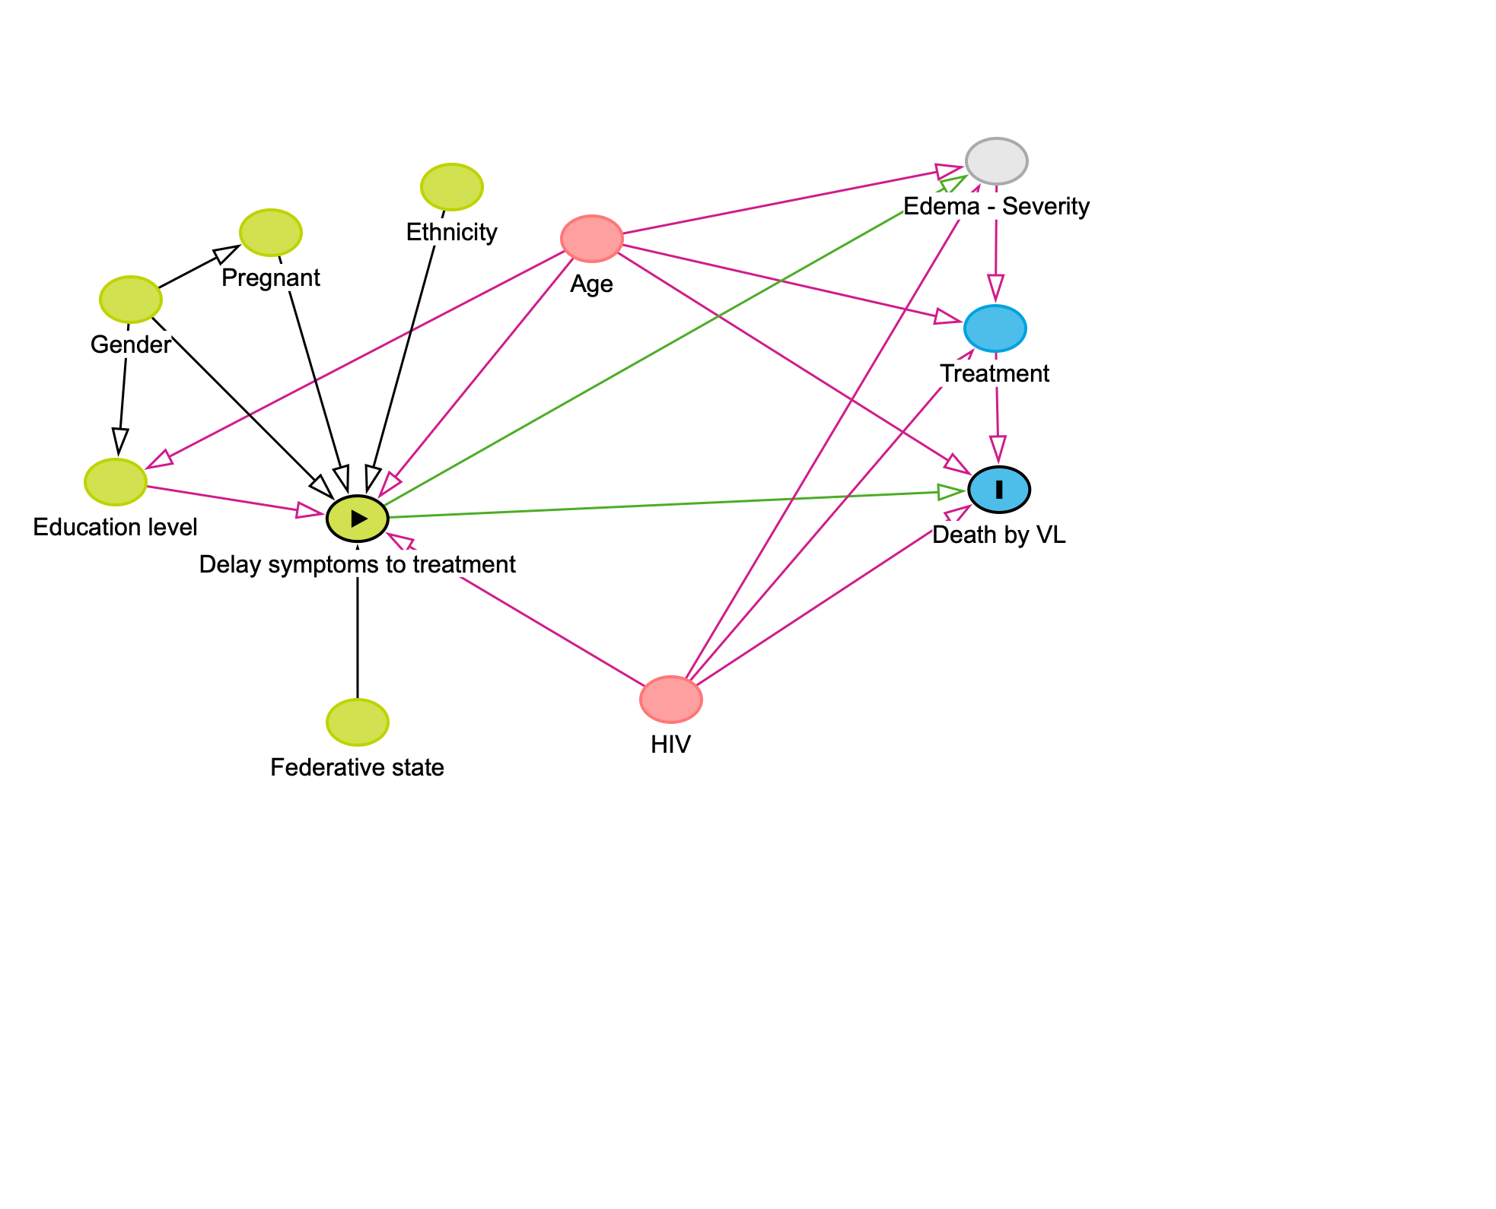
Supplementary figure 1. Direct Acyclic Graph, evaluation of the variable of interest and potential

Table Sxxx
Region | Normal | log-normal | Gamma | Cauchy | log Mean | log SD | Gamma shape | Gamma rate
Overall | 32,153.631 | 28,515.960 | 28,690.714 | 30,277.309 | 3.270 | 1.130 | 1.011 | 0.022
Center-West | 32,153.631 | 28,515.960 | 28,690.714 | 30,277.309 | 3.270 | 1.130 | 1.011 | 0.022
North | 72,160.892 | 63,106.904 | 63,846.390 | 66,648.675 | 3.110 | 1.012 | 1.158 | 0.032
Northeast | 195,545.180 | 176,537.560 | 176,289.369 | 185,633.794 | 3.342 | 1.126 | 1.075 | 0.022
South | 1,195.894 | 1,113.658 | 1,109.343 | 1,175.733 | 3.772 | 1.044 | 1.238 | 0.018
Southeast | 76,425.046 | 67,266.686 | 68,044.306 | 71,268.209 | 3.279 | 1.053 | 1.085 | 0.024

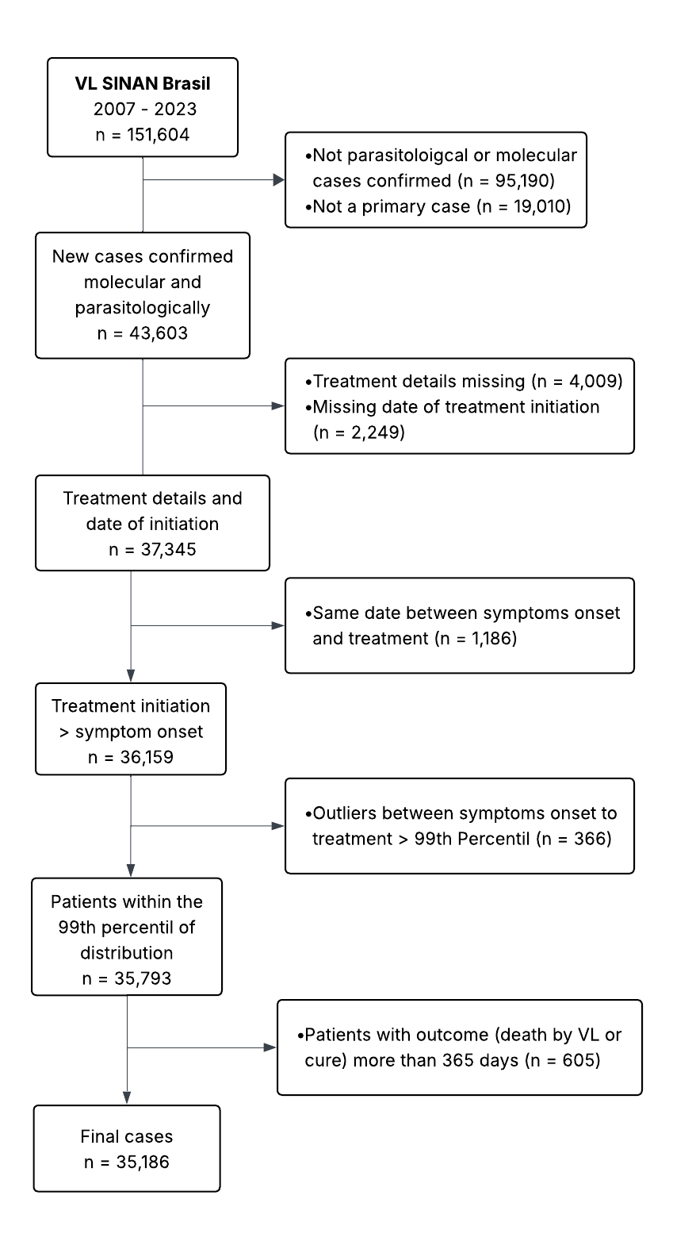
Supplemental figure 1: Trial profile

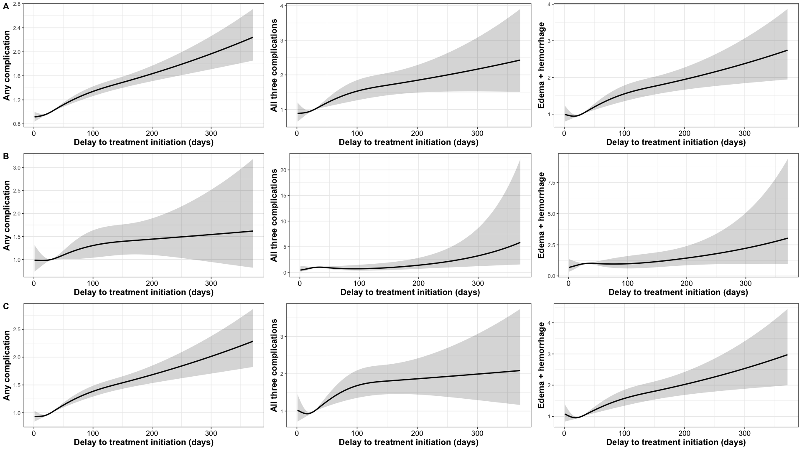
Supplemental Figure 2. Evaluation of the odds ratio according to the presence of symptoms for all of them (jaundice, oedema and haemorrhage), some of them and just Oedema and haemorrhage, and the relationship with delay in treatment initiation in the HIV population.

Table S1. Distribution of median time from treatment initiation to outcome treatment
Characteristic | Cure  median [range] days (t_{t}–t_{c})¹ | Death  median [range] days (t_{t}–t_{m})¹ | Overall  median [range] days (t_{t}–t_{o})¹
Age group
0-1 | 26 [1-342] | 7 [1-163] | 23 [1-342]
1-5 | 28 [1-353] | 6 [1-206] | 26 [1-354]
16-50 | 28 [1-365] | 7 [1-265] | 26 [1-365]
6-15 | 28 [1-363] | 6 [1-133] | 27 [1-363]
>50 | 23 [1-365] | 7 [1-131] | 19 [1-365]
Gender
Female | 27 [1-365] | 7 [1-206] | 25 [1-365]
Male | 27 [1-365] | 7 [1-265] | 25 [1-365]
Region
Center-West | 27 [1-363] | 7 [1-255] | 24 [1-363]
North | 32 [1-365] | 7 [1-265] | 30 [1-365]
Northeast | 26 [1-364] | 7 [1-206] | 24 [1-364]
South | 14 [1-196] | 4 [2-129] | 12 [1-196]
Southeast | 25 [1-350] | 7 [1-110] | 22 [1-362]
Race/colour
Afro-descendants | 28 [1-365] | 5 [1-206] | 26 [1-365]
Brown | 28 [1-365] | 7 [1-265] | 25 [1-365]
Indigenous | 24 [1-302] | 7 [1-22] | 20 [1-302]
Unknown | 24 [1-364] | 5 [1-129] | 21 [1-364]
White | 26 [1-314] | 7 [1-162] | 24 [1-362]
Yellow | 28 [1-327] | 8 [2-20] | 25 [1-327]
Signs and Symptoms
Fever | 27 [1-365] | 7 [1-265] | 25 [1-365]
Oedema | 28 [1-363] | 6 [1-206] | 24 [1-363]
Weight loss | 28 [1-365] | 7 [1-265] | 26 [1-365]
Cough and dyspnoea | 28 [1-365] | 7 [1-255] | 25 [1-365]
Splenomegaly | 28 [1-365] | 7 [1-255] | 25 [1-365]
Haemorrhage | 26 [1-363] | 6 [1-206] | 21 [1-363]
Hepatomegaly | 27 [1-365] | 7 [1-255] | 25 [1-365]
Jaundice | 28 [1-365] | 6 [1-206] | 25 [1-365]
HIV status
No | 27 [1-365] | 7 [1-265] | 25 [1-365]
Yes | 23 [1-327] | 8 [1-255] | 21 [1-362]
Treatment
Amphotericin B deoxycholate | 24 [1-342] | 6 [1-206] | 21 [1-342]
Antimonial Pentavalent | 31 [1-364] | 9 [1-163] | 29 [1-364]
Liposomal amphotericin B | 18 [1-365] | 6 [1-265] | 16 [1-365]
Others | 29 [1-317] | 8 [1-29] | 24 [1-317]
¹Time between treatment initiation (t_{t}) and outcome
t_{c} = time to cure, t_{m} = time to death, t_{o} = time to outcome

Characteristic | Cure  N = 26,333¹ | Death for VL  N = 2,089¹ | Overall  N = 28,422¹ | p-value²
Age group |  |  |  | <0.001
0-1 | 1,771 (6.7%) | 181 (8.7%) | 1,952 (6.9%)
1-5 | 7,309 (28%) | 263 (13%) | 7,572 (27%)
6-15 | 3,904 (15%) | 72 (3.4%) | 3,976 (14%)
16-50 | 9,921 (38%) | 764 (37%) | 10,685 (38%)
>50 | 3,428 (13%) | 809 (39%) | 4,237 (15%)
Gender |  |  |  | 0.13
Female | 9,486 (36%) | 718 (34%) | 10,204 (36%)
Male | 16,845 (64%) | 1,371 (66%) | 18,216 (64%)
Race/Color |  |  |  | <0.001
Afro-descendants | 2,097 (8.1%) | 198 (9.6%) | 2,295 (8.2%)
Brown | 18,183 (70%) | 1,345 (66%) | 19,528 (70%)
Indigenous | 243 (0.9%) | 32 (1.6%) | 275 (1.0%)
Unknown | 1,219 (4.7%) | 141 (6.9%) | 1,360 (4.9%)
White | 3,881 (15%) | 318 (15%) | 4,199 (15%)
Yellow | 189 (0.7%) | 18 (0.9%) | 207 (0.7%)
Period |  |  |  | <0.001
2007-2009 | 5,432 (21%) | 323 (16%) | 5,755 (20%)
2010-2014 | 9,110 (35%) | 659 (32%) | 9,769 (35%)
2015-2018 | 7,369 (28%) | 642 (31%) | 8,011 (28%)
2019-2023 | 4,284 (16%) | 453 (22%) | 4,737 (17%)
Region |  |  |  | <0.001
Centre-West | 2,363 (9.0%) | 236 (11%) | 2,599 (9.1%)
North | 5,562 (21%) | 274 (13%) | 5,836 (21%)
Northeast | 12,464 (47%) | 1,017 (49%) | 13,481 (47%)
South | 81 (0.3%) | 12 (0.6%) | 93 (0.3%)
Southeast | 5,863 (22%) | 550 (26%) | 6,413 (23%)
HIV |  |  |  | <0.001
No | 19,254 (73%) | 1,464 (70%) | 20,718 (73%)
Yes | 1,830 (6.9%) | 243 (12%) | 2,073 (7.3%)
Unknown | 5,249 (20%) | 382 (18%) | 5,631 (20%)
Days symptoms to treatment | 27 (14,54) | 30 (14,65) | 27 (14,55) | <0.001
Treatment |  |  |  | <0.001
Amphotericin B deoxycholate | 3,054 (12%) | 489 (23%) | 3,543 (12%)
Antimonial Pentavalent | 16,468 (63%) | 696 (33%) | 17,164 (60%)
Liposomal amphotericin B | 6,058 (23%) | 861 (41%) | 6,919 (24%)
Others | 753 (2.9%) | 43 (2.1%) | 796 (2.8%)
¹n (%); Median (Q1,Q3)
²Pearson's Chi-squared test; Wilcoxon rank sum test

